**THEVININ THEOREM**

**LAB # 10**



**Spring 2023**

**CSE103L Circuits & Systems-I Lab**

Submitted by: **TARIQ JAMIL**

Registration No. : **22PWCSE2184**

Class Section: **A**

“On my honor, as student of University of Engineering and Technology, I have neither given nor received unauthorized assistance on this academic work.”

Student Signature: ______________

Submitted to:

***Dr. Muniba Ashfaq***

Date: 13 June 2023

Department of Computer Systems Engineering

University of Engineering and Technology, Peshawar

**TITLE:**

Thevenin’s theorem.

**Objective:**

The objective of this lab is,

* To learn about thevenin theorem.
* To solve the problem related to thevenin theorem.
* To learn about Rth, Vth.

**Definition:**

Thevenin theorem states that any linear circuit containing several voltage sources and resistors can be simplified to a Thevenin equivalent circuit with a single voltage source and resistance connected in series with a load.

**Problem**

To find the value of Rth, Vth.

**Diagram:**

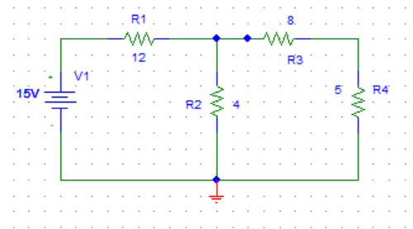

**Solution:**

We solve this problem in notebook. First we find Vth and then Rth.

**Practical**

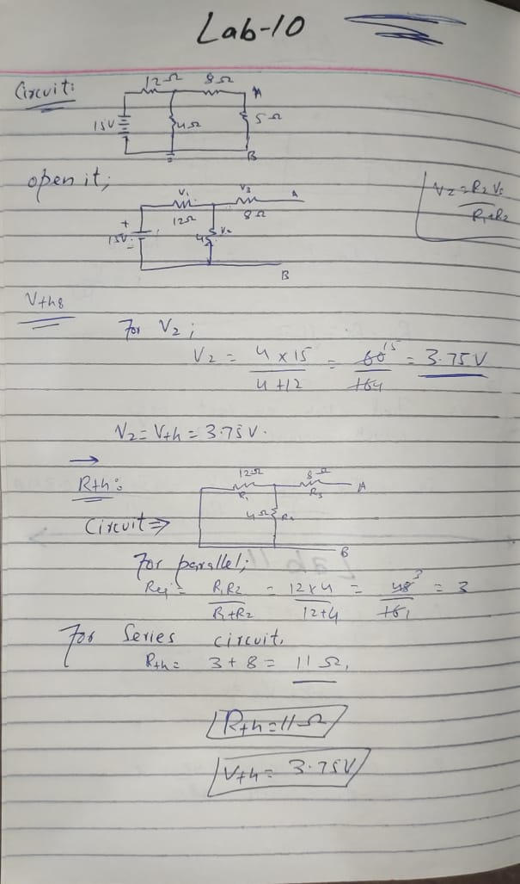

So we will get Vth = 3.75 V and Rth = 11ohm which is proved in notebook.

**Difference between thevenin and Norton theorem:**

Thevenin's Theorem utilises a voltage source, while Norton's Theorem uses a current source. Norton's Theorem employs a resistor set in parallel over the source, whereas Thevenin's Theorem utilises a resistor in series. From Thevenin's Theorem, Norton's Theorem can be easily derived.

**Conclusion:**

We solve the problem related to thevenin theorem.

**LAB RUBRICS: (Circuits & Systems-I Lab)**

|  |  |  |  |  |
| --- | --- | --- | --- | --- |
| **Criteria & Point**  **Assigned** | **Outstanding**  **4** | **Acceptable**  **3** | **Considerable**  **2** | **Below Expectations**  **1** |
| **Attendance and Attentiveness in**  **Lab**  PLO10 | Attended in proper  Time and attentive in Lab | Attended in proper  Time but not attentive in Lab | Attended late but attentive in Lab | Attended late not attentive in Lab |
| **Equipment / Instruments Selection and Operation**  PLO1,  PLO2,  PLO3,  PLO5, | Right selection and operation of appropriate equipment and instruments to perform experiment. | Right selection of appropriate equipment and instruments to perform experiment but with minor issues in operation | Needs guidance for right selection of appropriate equipment and instruments to perform experiment and to overcome errors in operation | Cannot appropriately select and operate equipment and instruments to perform experiment. |
| **Result or Output/ Completion of target**  **in Lab**  PLO9, | 100% target has  been completed and well  formatted. | 75% target has been  completed and well formatted. | 50% target has  been completed but not well formatted. | None of the  outputs are  correct |
| **Overall, Knowledge**  PLO10, | Demonstrates excellent  knowledge of lab | Demonstrates good  knowledge of lab | Has partial idea about the Lab and  procedure followed | Has poor idea about the Lab and  procedure followed |
| **Attention to Lab Report**  PLO4, | Submission of Lab Report in Proper Time i.e. in next day of lab., with proper  documentation. | Submission of Lab Report in proper time but not with proper  documentation. | Late Submission  with proper  documentation. | Late Submission Very poor  documentation |